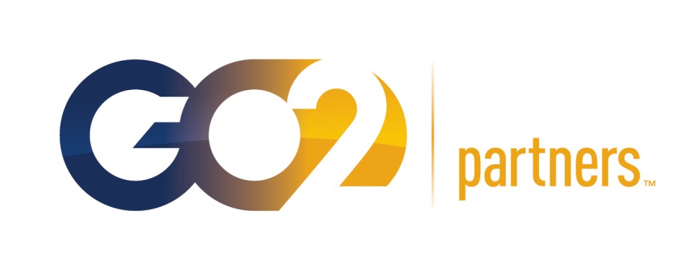

Contact: James O’Brien, Partner
Phone: (847) 699-2999
Email: ob@go2partners.com
FOR IMMEDIATE RELEASE

May 22, 2014

PRINT MANAGEMENT PARTNERS REBRANDS AS GO2 PARTNERS

DES PLAINES, IL — Print Management Partners has recently made the decision to change its corporate brand identity to GO2 Partners. This rebranding is the result of an internal campaign designed to build collaboration amongst GO2 Partners’ various fields of expertise. The transformation also represents an evolution in the company’s core business offerings.

Founded in 1995, GO2 Partners served primarily as a print distributor. Through the years, the company’s success has allowed it to grow and expand into new industries ─ building capabilities and knowledge along the way. This once small company with a single function has flourished into a robust, multipurpose organization with 8 locations throughout the Midwest.

“We now offer more to our clients than ever before, and we continue to expand our breadth of services every year,” says James O’Brien, Managing Partner. However, this growth had also created silos of expertise. As each area of GO2 Partners quickly and profoundly evolved to serve the core needs of its own customers, each silo became more and more distinct. “There were certainly times when we struggled to bridge the gaps in geography and expertise,” says O’Brien. “We needed to promote collaboration.”

This ultimately culminated in a new name for the company, GO2 Partners, and a reassessment of its four core divisions, which will now be represented as GO2 Advertising, GO2 Print Solutions, GO2 Supply Chain Solutions, and GO2 Lab Media. “We see these four competencies as creation, execution, distribution, and specialization”, O’Brien asserted.

“These changes will further enhance our ability to introduce new business communication solutions and increase our capacity to deliver more expertise,” says O’Brien. Nevertheless, the company’s fundamental principles have remained the same ─ be the easiest company to do business with by ensuring all projects are on time, on target, and on budget.

Today, GO2 Partners delivers exceptional business communication solutions ─ from advertising and marketing services, through print management, supply chain solutions and lab media. Still, the company has not forgotten the importance of backing every solution with superior customer service and the power of employee ownership.

About GO2 Partners
GO2 Partners delivers exceptional business communication solutions and unmatched marketing services, backed by the power of employee ownership. Our entrepreneurial spirit and strategic executions deliver a flexible partnership; we are motivated to achieve results.

Our brands include:
GO2 Advertising: Our strategic advertising initiatives elevate our clients’ brand.
GO2 Print Solutions: We develop, distribute and manage all of our clients’ printed materials.
GO2 Supply Chain Solutions: Our reliable supply chain management creates a lower cost of ownership.
GO2 Lab Media: We are the responsible partner for lab testing communications materials.
# # #
For more information, or to schedule an interview, please contact James O’Brien at (847) 699-2999 or ob@go2partners.com.

